

**Submitted by:**

Burhan Baig

**Referred to:**

Sir. Muhammad Affan

**Roll no:**

460945

Fundamentals of Programming

Assignment no. 4

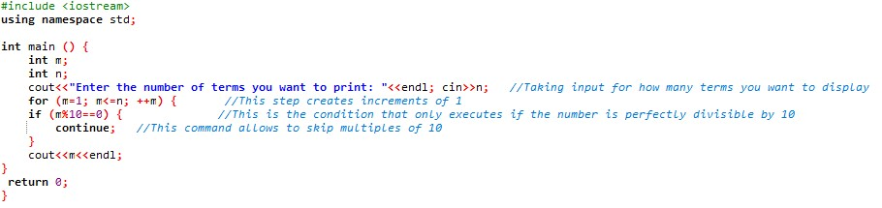**TASK 1**

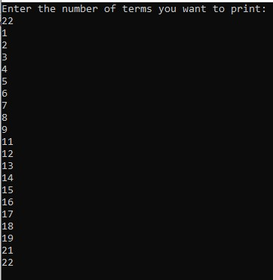

# **Task 2**

# **TASK 3**

